E. Signed Apk

Screen Shot # 1 Main Page

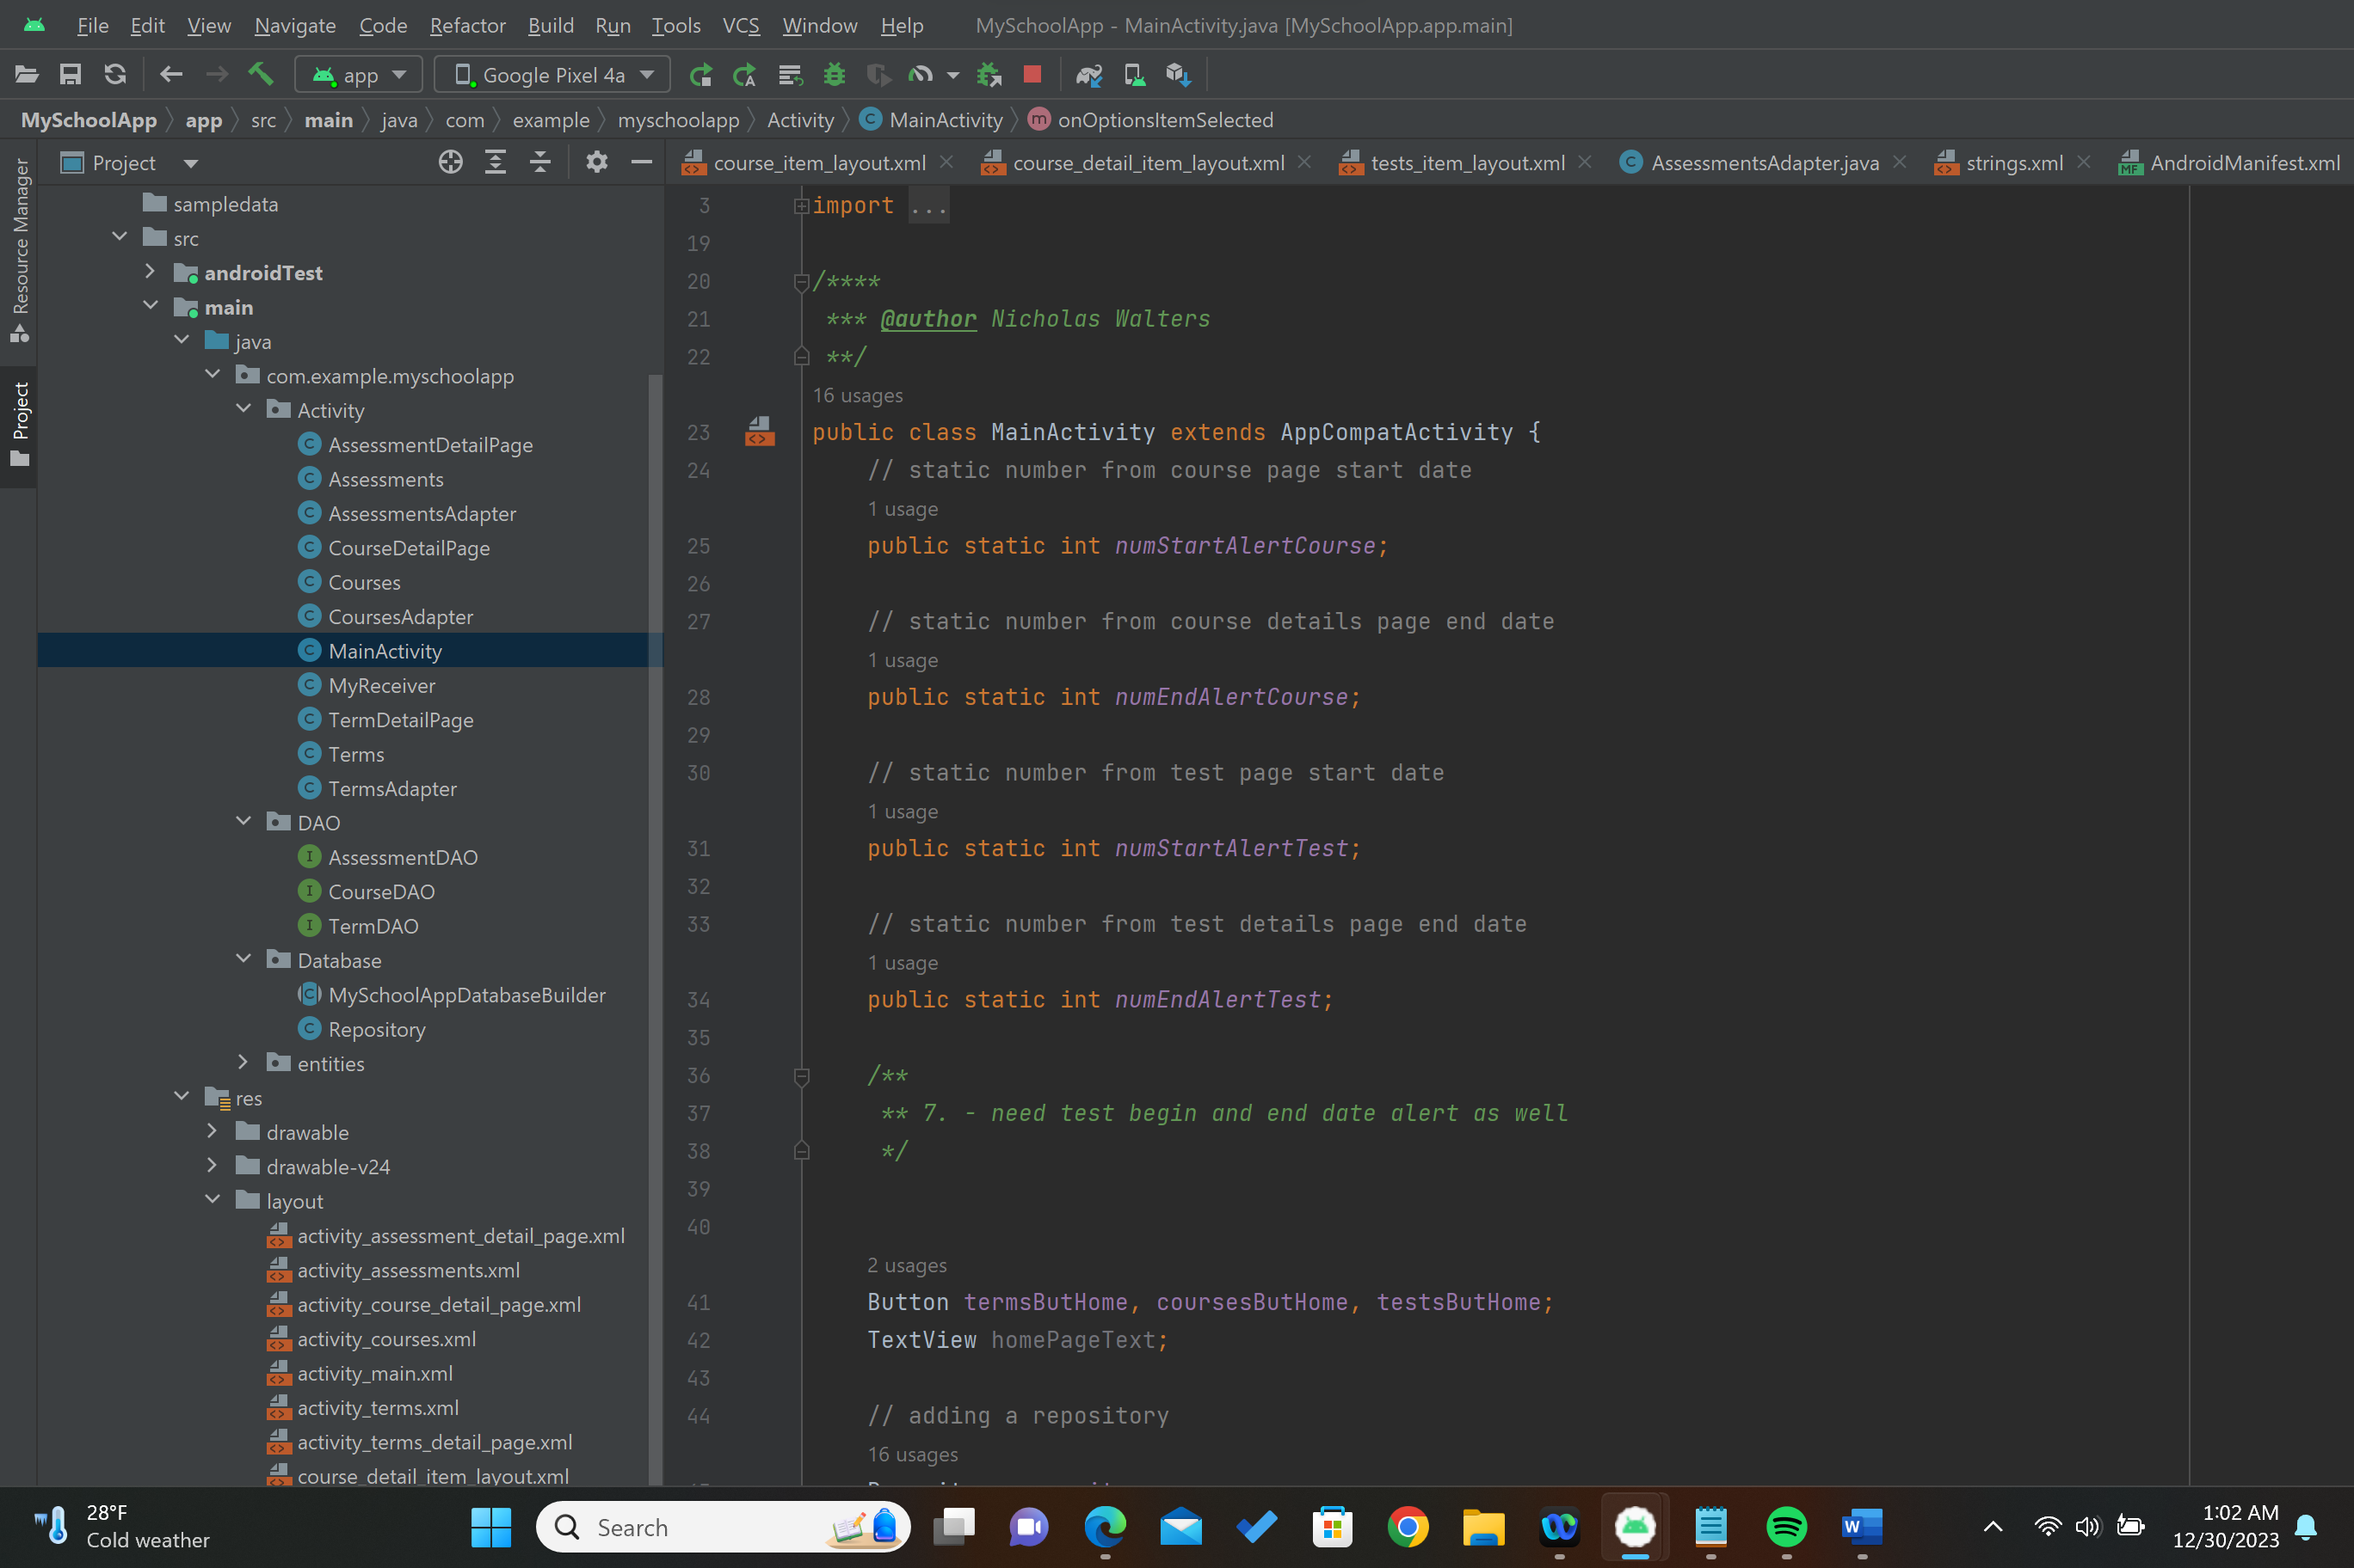

Step 1. Click on Build

Step 3. Select APK and next

Step 4. Creating a new key store file, click on create new

Step 5. Providing the path for the key store

Step 6. Creating a new folder naming it keyStore

Step 7. Got a new file named it keyStore1

Step 8. Filling out the form

Step 9. Click ok and then next

Step 10. Release version and create

Step 11. Got screenshot of it being successfully created.

Step 12. Got the screenshot of where it is located to release it to google play store

Step 13. Got the screenshot of it running successfully.

